Sangha Auto Notices Guide

# Introduction

Sangha Auto Notices (Automatic Notices) allows district and school administrators to send notifications to parents through multiple channels, including the Sangha smartphone app, email, SMS/text and voice calls. Auto Notices are template driven, combining or transforming data imported from CSV text files with the SIS information contained within Sangha, and can be scheduled to run automatically or manually on demand. This guide covers an attendance notification process that North Vancouver School District’s school administrators can run manually based on a data extract from MyEdBC.

# Configuring an Auto Notice for Attendance

Auto Notices are configured in a reserved area of Sangha only accessible by district and school administrators. The home page lists existing Auto Notices under the Scheduled Notices tab, and a log of processed Auto Notices under the History tab.

Auto Notices are composed of three elements:

* Source, which defines the CSV file name, columns contained in the CSV file, columns that need to be added from Sangha and any send conditions that can be used to filter the data. Columns define the data type of the CSV fields and can be used to transform data such as date formats.
* Content, which defines the template of the Auto Notice that will be sent to parents. Static text combined with “merge fields” are used to generate the unique Auto Notices from the source data extract, like a mail merge in a word processor.
* Delivery, which controls the schedule and channels that the Auto Notices are sent on. As this Auto Notice will be sent manually, the schedule is not required.

Follow the steps below to create a new Auto Notice based on the MyEdBC attendance extract:

1. Click the Add Notice button

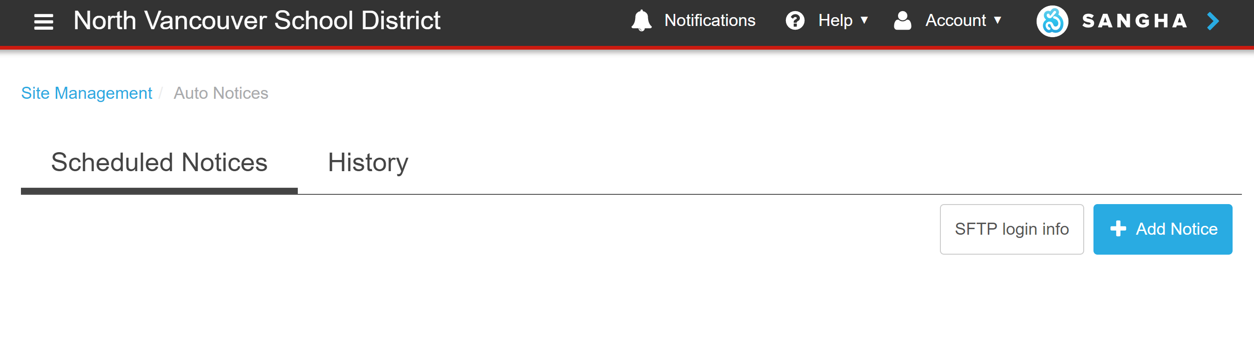

1. Define the Auto Notice name, source, columns and send conditions required by the Auto Notice.
   1. Enter a name in the Auto notice name field, such as ‘Attendance Auto Notice’.



* 1. Supply the source CSV file name, such as attendance.csv – the name of the actual source file does not have to match as this Auto Notice will be run manually.

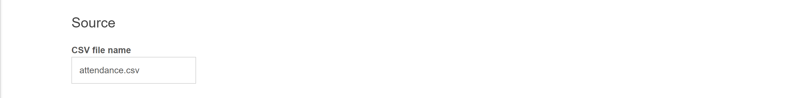

* 1. Define the columns based on those contained in the source CSV file, a sample of which is shown below. Column Names must match those defined in the CSV file, and a Data Type selected from the available types - Student ID, Text, Number and Date. Student ID is the only mandatory data type, and the default Column Name has been renamed from ‘studentID’ to ‘Pupil ID’ in this scenario. Columns containing dates must have the correct format selected.

"Pupil #","Name","Date","Code","Period","Description"

"652714","Sovernigo, Amalia","22/06/2018","A","Period 01","ENGLISH LANGUAGE ARTS 9"

"652236","Stapelmann, Noah","22/06/2018","A","Period 01","ENGLISH LANGUAGE ARTS 9"

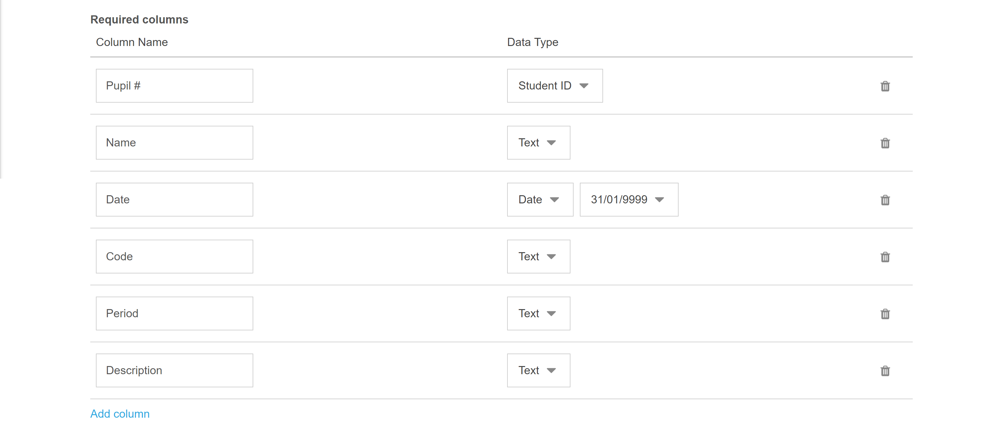

* 1. Send conditions can be used to filter entries from the source CSV file before they are sent. In this scenario, only records where the ‘Code’ column equals ‘A’ will be sent.

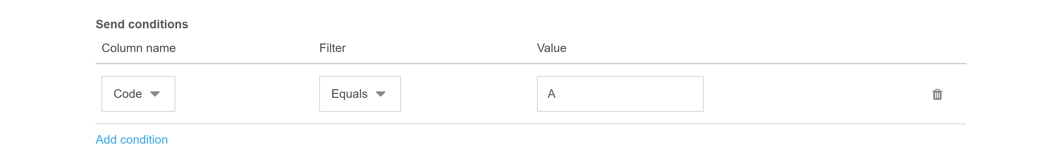

1. The contents of the Auto Notice are defined by combining static text and tokenized merge fields that can come from the source CSV file or Sangha’s SIS information about each student.
   1. Enter the desired text into the editor area and insert ‘System Fields’ or ‘CSV Fields’ in-line with the text.

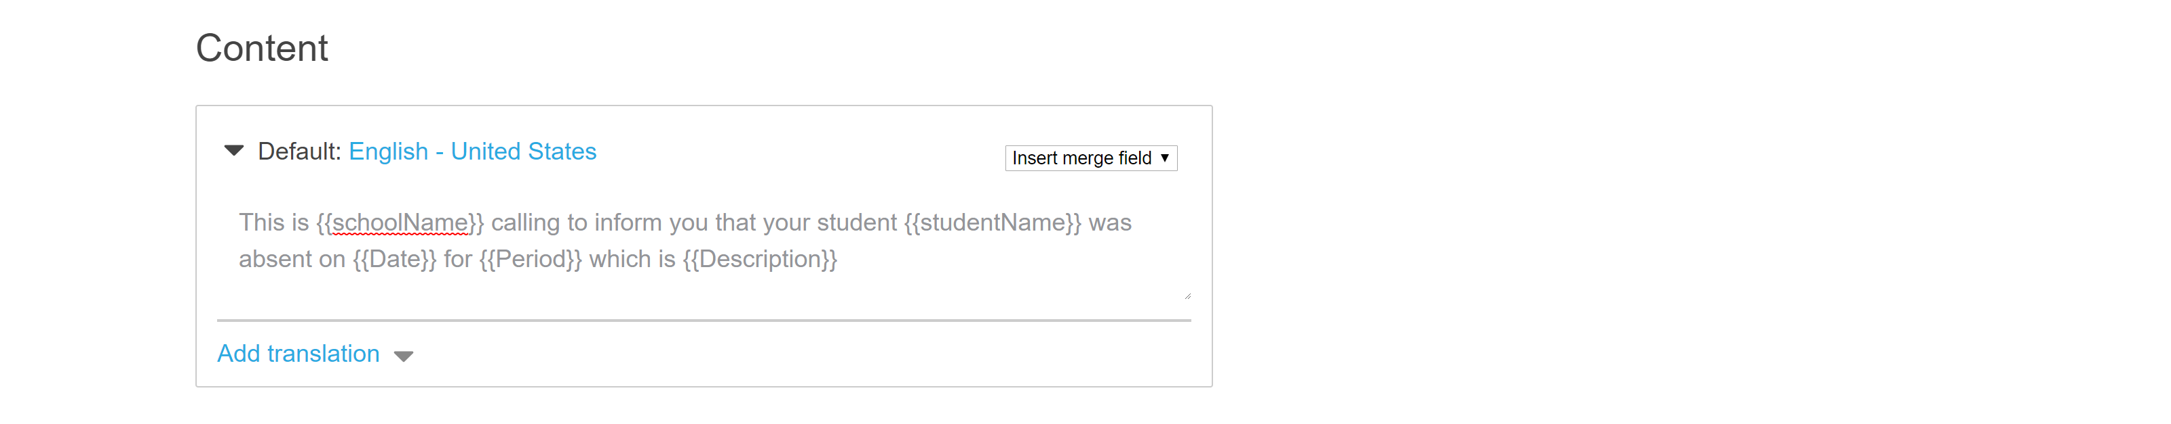

1. As Delivery will be manual in this scenario, many of the setting are not required and can be left as defaults. However, Delivery controls the channels used for the Auto Notice and can be altered between non-intrusive (Smart Notifications) based on the parent’s setting or sent on all channels. Initially, they should be sent on the required channels and as Voice messages.

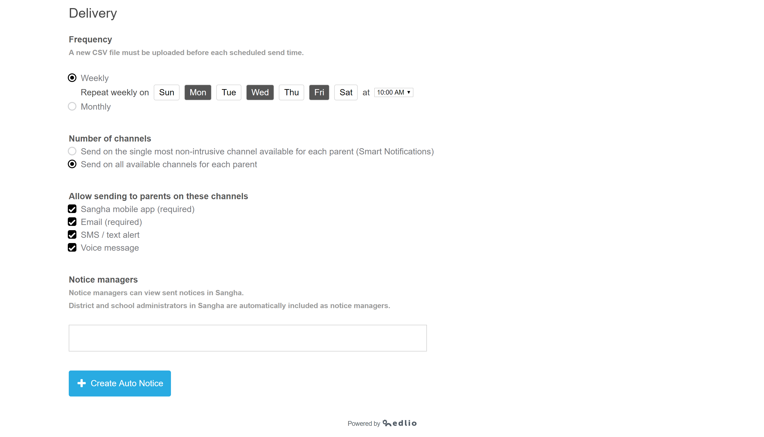

1. Complete the configuration steps by clicking ‘Create Auto Notice’.

# Loading MyEdBC Attendance Data

Auto Notices that rely on a manual data upload will remain in ‘Waiting for data’ status until a district or school administrator is ready to process their attendance, which is described below.

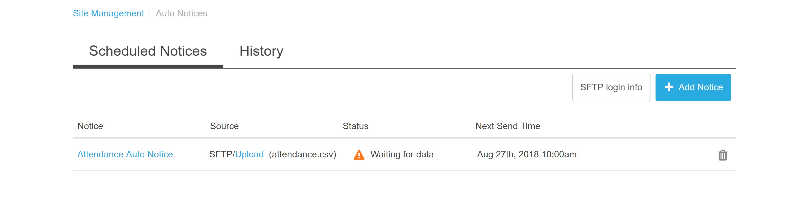

1. Clicking ‘Upload’ brings up a standard file selection dialog, allowing the administrator to select the source CSV file that they’d like to process.

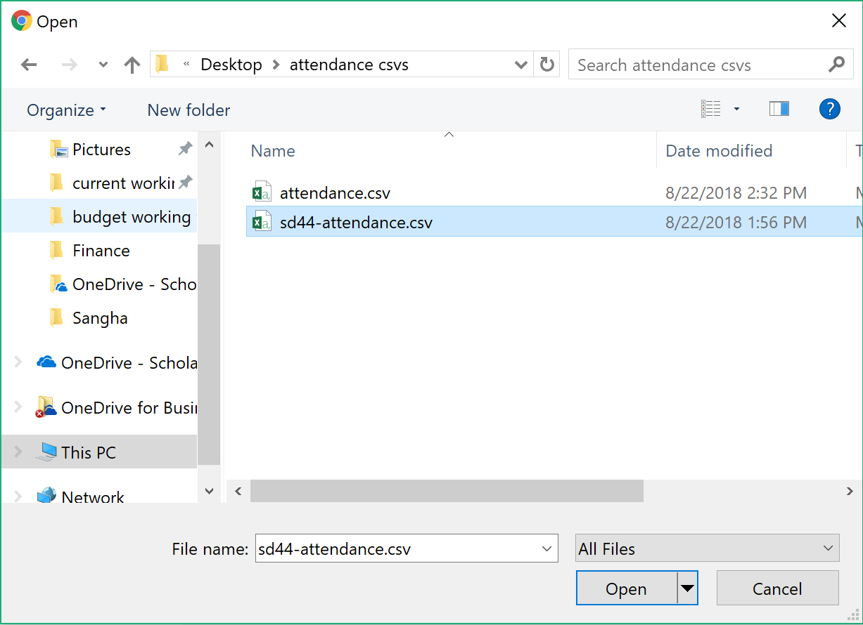

1. The source CSV file is processed by Sangha and the administrator is presented with the History tab showing the status of the import and the number of records it contained.

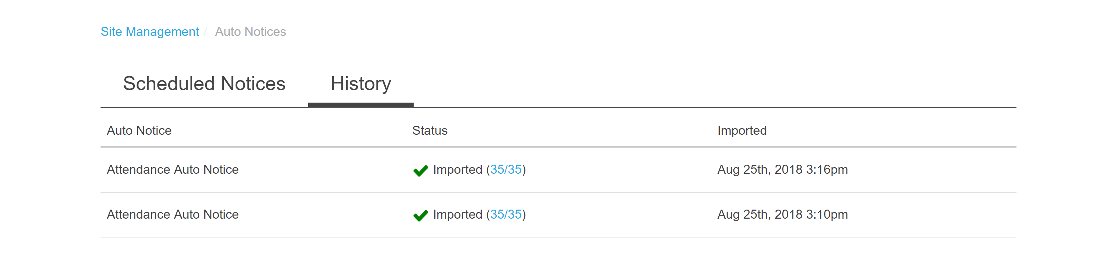

1. Clicking on the Scheduled Notices tab shows that the Auto Notice status has changed to ‘Ready to send’ and the number of notifications that will be sent. If there are any changes required, the administrator can click ‘Upload’ to provide a new source CSV file.

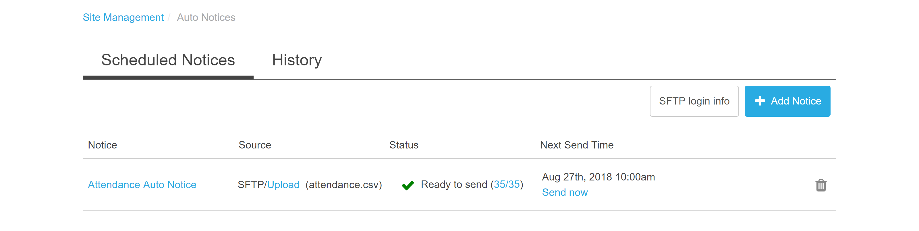

# Sending and Monitoring Auto Notices

Clicking ‘Send now’ initiates the process of sending notifications to parents, which results in a Sangha app notification, email, and voice call. Once complete, the Auto Notice returns to the ‘Waiting for data’ state and is ready for a new source CSV file.

Monitoring Auto Notices is done through the regular Sangha web application under the ‘Auto notices’ tab available to district and school administrators. A summary view shows recent Auto Notices for a given school. **Please note the following images are examples from a test environment.**

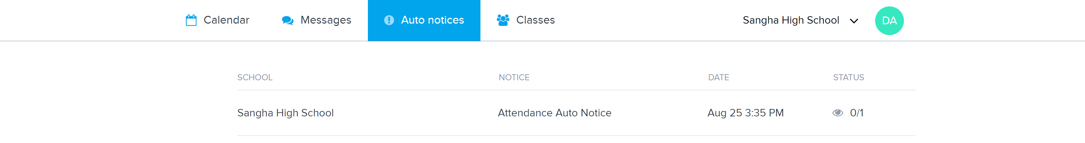

Clicking on an entry in the ‘Notice’ column brings up a summary of the Auto Notice for each student it related to, showing the contents of the notification and the channels it was sent on.

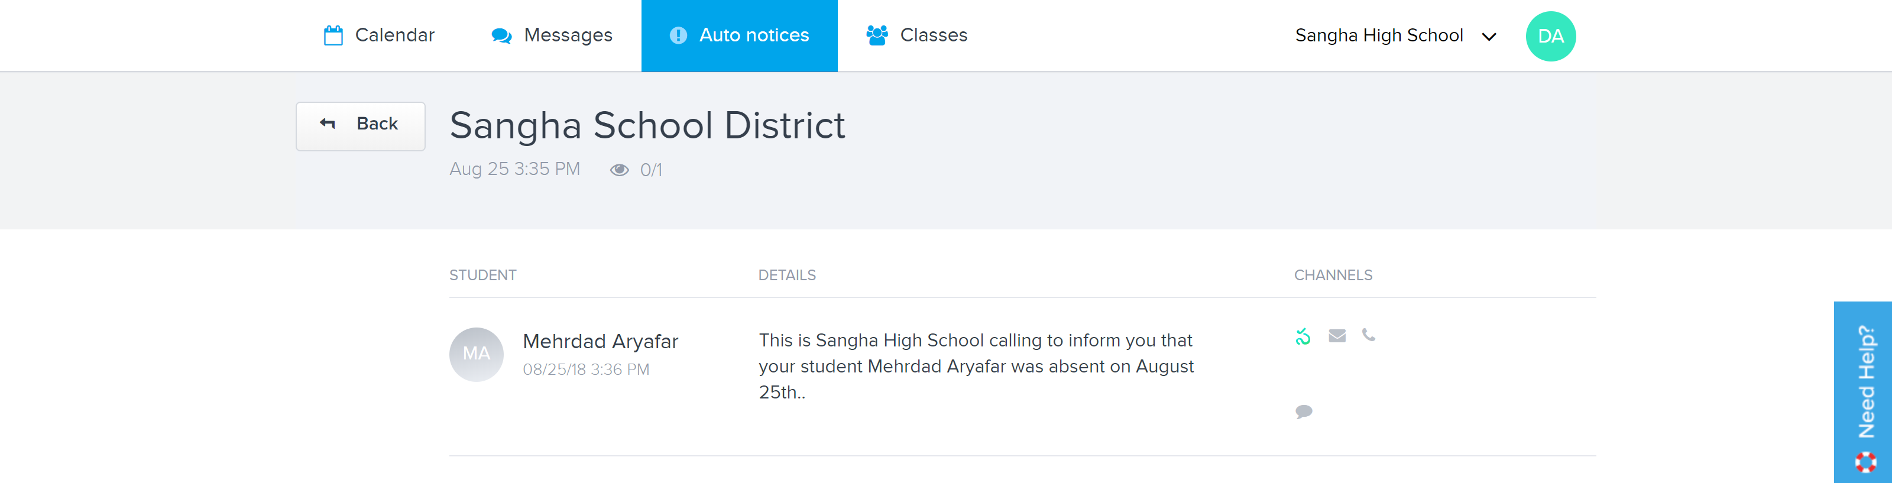

Clicking on a student brings up a detailed view of the notification, including the full notification message and the parents/guardians it was sent to.

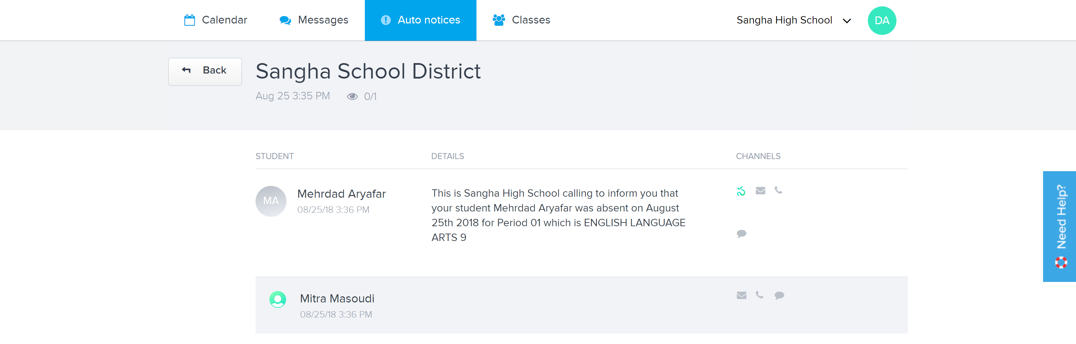

Sample voicemail message:

